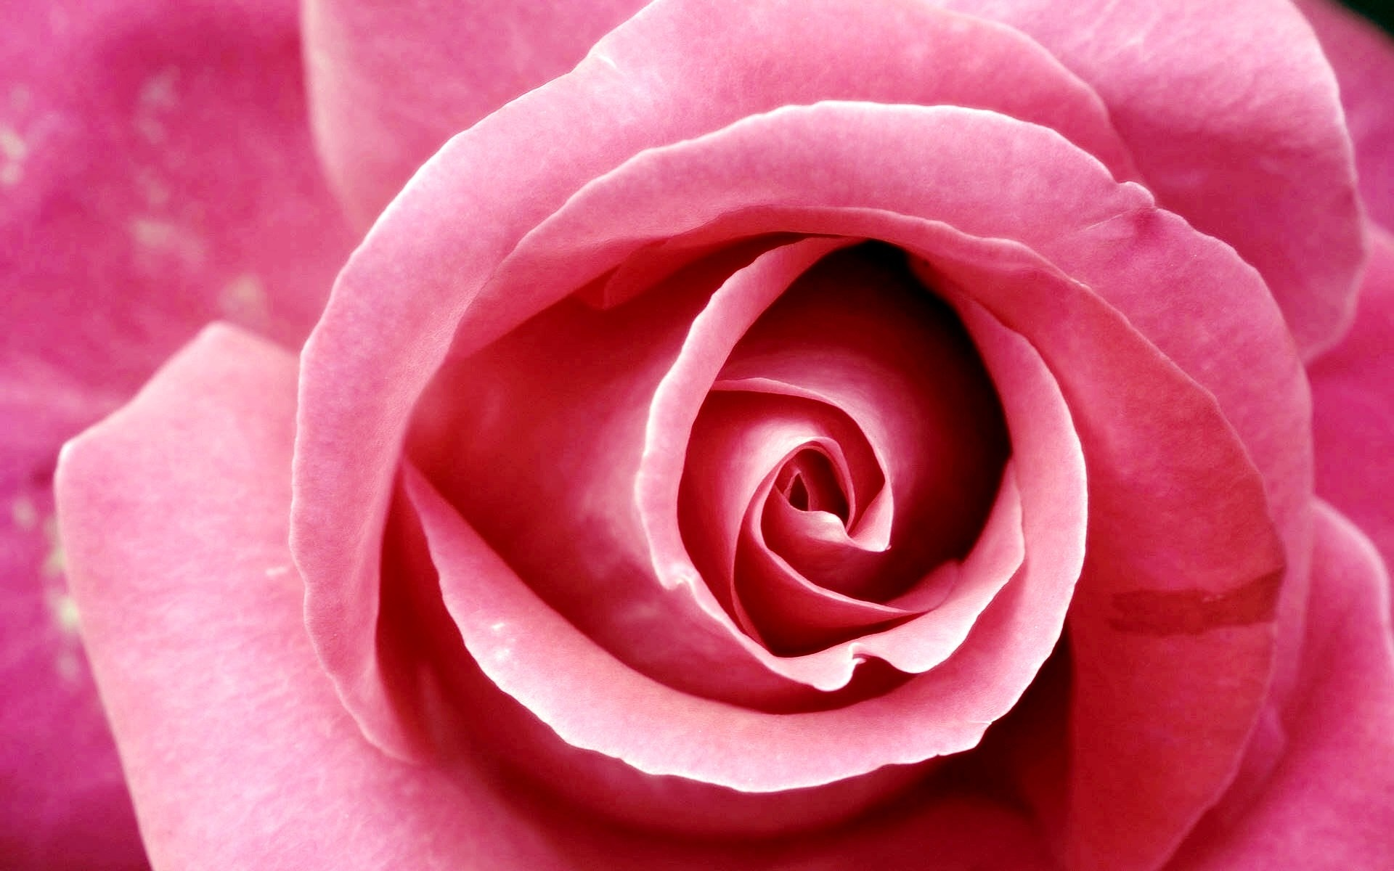
Birthing

“I must be the Virgin and give birth to God.”
–Angelus Silesius
17th c. German mystic

"What good is it to me if Mary gave birth to the Son of God fourteen hundred years ago and I do not also give birth to the Son of God in my time and in my culture? We are all meant to be Mothers of God."
-Meister Eckhart
15th c. German mystic

the Holy

A Contemplative & Creative Journey
Through Advent

- A 4-week online Celtic Spirituality retreat during advent: 12/1st -12/28th http://abbeyofthearts.com/classes/online-classes/birthing-the-holy/

- A Mosaic Workshop to create a sacred icon: Sat/Sun Dec 14th /15th, Sat 10am-3pm, Sun 1-6pm @ Spiral Mosaics in Gorse Mill Studios, 31 Thorpe Rd., Needham

- Drop-in studio hours to work at your own pace: Mondays 12/9, 12/16 10am-1pm; Thursdays 12/12, 12/19 5-8pm (to be scheduled in advance)

Do you long to make the season of Advent a more meaningful time of prayer and reflection? Do you want to make space to listen to your deepest call in this season of birthing?
Online Retreat led by Abbey of the Arts http://abbeyofthearts.com/classes/online-classes/birthing-the-holy/with Christine Valters Paintner and guest teachers and artists Dara Molloy, Betsey Beckman, and Richard Bruxvoort Colligan

Each of us is called to participate in bringing God to birth in the world. We each hear our own annunciations and invitations to enflesh the sacred creative call of our hearts in service to others. The season of Advent invite us into a profound reflection on this invitation and the movement toward birthing. The weeks of the Advent season offer us archetypal themes to ponder each calling us to take our creativity seriously. This year's Advent retreat will bring the gifts of the Celtic Christian imagination to guide our reflection. We will draw upon the themes and ideas that nourished the ancient Irish monks.

RSVP to Emily at emilynj@imagodeifund.org and I will include you in the group registration for the online retreat. The cost is being subsidized to offer this as a ministry of soul care. Donations are accepted in a basket in the studio to help offset material costs.

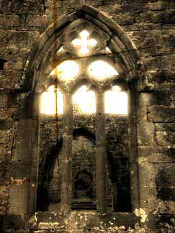
enter in…

